**A Manual for Creative Citizens:**

***Design Study of***

***Hong Kong’s Self-Built Communities***

**Louise Wong**

**Co-edited by Yanki Lee & Sara Wong**

**With contributions from**

**/Liesbeth Huybrechts**

**/Will Davis**

**and**

**Interview with Wong Hung**

Published by

Hong Kong Design Institute, 3 King Ling Road, Tseung Kwan O, New Territories, Hong Kong, China

Copyright © 2017 by HKDI DESIS Lab for Social Design Research

Except where otherwise noted, this work is licensed under <http://creativecommons.org/licenses/by/3.0/>

Notice – For any reuse or distribution, you must make clear to others the license terms of this work.

Author: Louise Wong

C0-editors: Dr. Yanki Lee and Sara Wong

Contributors: Dr. [Liesbeth Huybrechts](https://www.facebook.com/liesbit), Will Davis and Prof Wong Hung

Design Direction: Tianju Duan

Printed in XXXX

First Printing, XXXX, XXXX copies

Library of Congress Cataloguing-in-Publication Data

ISBN: xxxxxxxxxxxxx

**CONTENT**

00//A Book for All Self-Builders _ Louise Wong 4

01// What is a Self-Built Community? _ Will Davis 7

02// Guided Tour _ Where are the self-built communities? 10

03// Preface _ The role of self-built communities in designing the city _ by Liesbeth Huybrechts 11

04// Self Build Community Cases in Hong Kong _ Who are they? 26

05// Interview with Prof Wong Hung _ The Society of Homeless 27

On Before and After Occupy 27

Different Mutual Relationships 28

Self-built Homes 28

Boundary? 29

06// Phenomena _ how do self-builders live? 30

07// Editor note: Permanently Temporary: Home of Urgency in Urban Hong Kong _ Yanki Lee & Sara Wong 31

# 00//A Book for All Self-Builders _ Louise Wong

**Where:**

Hong Kong is our city and our site for experiment. It is one of the most expensive cities in the world. Scarcity of buildable land and surging property prices form the backdrop for this project in which we look at the space in-between and the informal approaches to living that creative citizens are taking across the territory of Hong Kong. It exemplifies the diverse patterns of living found in Hong Kong, a contemporary megacity.

**Why:**

The background of this project is based on my two years of fieldwork study with street-sleepers. Engaging with vulnerable groups such as homeless residents, as designers, requires a new approach to work with them and without stigmatising them. This is why I decided to employ a participatory design research approach with goal to start the project with appreciation of the ingenuity of the self-built communities who are politically named as homeless residents in Hong Kong. It is a combination of a landscape architecture study and ethnographic fieldwork in a social design approach to investigate the complex social environment of self-built/ temporary communities as urgency before they are wiped out permanently by political decision.

**What:**

*“The people who live under bridges enjoy an extremely open style of architecture… Le Corbusier (Architect) tended to produce closed architecture… standing and looking at his work at ground level, he will have recognised its immutability, but he will also have hoped that on the roof gardens people would rediscover open spaces.”*

Philippe Boudon, 1969. Live-in Architecture: Le Corbusier’s Pessac revisited

Inspired by Boudon’s study, I took one step forward. Instead of researching on residents’ responses to architect’s creations, I was exploring the concept of “Live-on Architecture”. With other design researchers’ participation, we started an intensive ethnographic fieldwork focusing on the self-built community (homeless residents/street-sleepers) under the flyover area (next to the Tung Chau Street Temporary Market) in Sham Shui Po, the oldest district in Hong Kong facing the problem of urban renewal in the future. How do self-builders constantly building their own private home by occupying the public spaces?

In traditional concept, living at home means living in a physical boundary defines a flat area, i.e. flat, department, house, etc. However, this concept may not exist in the present generation or even in the future. It is specifically crucial issue in urban situations like Hong Kong, which is ranked as the top 10 of global highest housing price. With high housing price and tiny space, different living patterns exist, no matter interior or exterior environment. Apart from the conventional living flat, other living models arise in the city, for instance, subdivided unit, cage home, movable living (park/street/24-hour shop/underpass), and self-built living. Various accommodating models show a varieties of living, it shows home can be different meanings, for instance, street or public space can be one part of your home, maybe street-home can be one of your living choices. Under different these models, it is vital to study how are they making use of space and resource in the urban area, what are the vernacular ingenuity of living and design in the community. The definition of “Home” and how we can “live on” our city has been challenged in this project with self-built community.

*"We make our homes ...we build the intimate shell of our lives by the organization and furnishing of the space in which we live. How we function as persons is linked to how we make ourselves at home... Inescapably, humans are homemakers."*

Abbarno, G.J.M, 1999. The Ethics of Homelessness: Philosophical Perspective

**How:**

The street-home, especially the mattress area, is the most private area of a self-builder, while gathering space for eating and chatting, cooking space, outdoor storage space, planting space and sleeping space are the five essential share spaces for street living. The self-built community shows the practice of street living and demonstrates the “living on” mode of informal/temporary uses of space in permanent urban infrastructure.

Self-built structure is an urban temporary and informal structure or light infrastructure. Except the self-built homes, different types of temporary and informal structures exit in the area nearby, for instance, self-constructed market, daytime offices for construction workers, movable storage space, movable hawker stall, etc. These temporary and informal structures are related to material, time and function factors. It is a new form of home with organic movement while an invisible negotiation of space happens between different self-builders.

Time and material would be the elements to represent its temporariness and informality, street-homes and self-builders change over time in the same location, apart from the permanent flyover infrastructure, other structures show the state of temporariness and informality, even the market block is named as temporary market.

**Acknowledgment**

I would like to thank all the self-builders I met during my study. Their lives were the inspiration of this book. Their living patterns, which I had analysed, formed the structure of the book. Through making this book, we hope to capture and share their tacit knowledge and inspire more citizens to think about the new possibilities with our streets and outdoor spaces.

I also would like to thank all the contributors of this book including Will Davis and Dr Liesbeth Huybrechts for their articles to unfold the issue that I am investigating into different directions. Appreciation also went to Professor Wong Hung for letting us to interview him. Making this book will not be possible without the support from HKDI DESIS Lab’s Graduate Trainee Programme and Design Trust Seed Project Fund. Finally, special thank should go to my co-editors: Sara Wong was my tutor during my study on Landscape Architecture and also the time when I started this investigation. Dr Yanki Lee and HKDI DESIS Lab team including Albert Tsang who mentored me throughout my 2 years as the graduate trainee on social design.

*Louise Wong graduated from Hong Kong Design Institute (HKDI) and Birmingham City University on Landscape Architecture. She was also selected to be one of the graduate trainees of the HKDI DESIS Lab for Social Design Research before she moved to Denmark to work at the Bjarke Ingels Group (BIG) since spring 2017.*

# 01// What is a Self-Built Community? _ Will Davis

This book is about the phenomena of creating, building and maintaining self-built communities in Hong Kong. We, a group of design researchers, are interested in expanding current understandings of the “self-built” phenomena; urban informality, floating communities and popular architecture. Thereby breaking down the assumptions associated with ‘homelessness.’ Along the way we play victim to the same categories applied to these social groups that describe how society has labeled them as “undesirable homeless,” for those that live outside of the traditional property market; “slum-dwellings” or “shanty towns” that describe dwellings that do not meet the standards set by a capitalist modernity. These social, urban categories are detrimental to the dignity of residents that find themselves labeled as such, and serve to entrench their position in society’s eyes as a problem groups to be dealt with. Hopefully this book can deliver new perspectives on how design can act as a framework to understand the mechanics of a multi-faceted and complex society, A society that often fails to acknowledge the design ingenuity of its citizens.

According to UN-Habitat, “slums” make up for 33% of the urban population in the developing world[1]. People living in these communities across the world share various attributes whilst producing highly-specific and idiosyncratic solutions to living in the environment in which they find themselves. Informal, floating communities such as those in this book use ingenious, quick-to-assemble design methods that re-occur in similar situations across the city—not only by the ‘homeless’—but as widespread popular design tools. This common ingenuity often goes unnoticed by urban design communities like those in Hong Kong. Yet if these designs were recognized as a key part of the cities vernacular, they could enrich our understanding of the complex ecology existing in our cities.

In the West, the idea of ‘vernacular’ architecture was popularised in 1964 with Bernard Rudovsky’s exhibition “Architecture Without Architects,”[2] celebrating ‘indigenous’ forms of building. In the exhibition Rudovsky scans the horizon for architectural indigenousness, finding nomadic dwellings such as mud huts which exist outwith the traditional model of architectural education. What is notable about Rudovsky’s idea, particularly then, was the repositioning of architecture as “the art of building,” and to consider the art form a universal phenomenon. Good design is all around us, if only we could see and appreciate it. Unfortunately, conventional planning approaches to slums and slum dwellers continues to be paternalistic, as Jane Jacobs noted three years prior to Rudovsky’s exhibition in her 1961 book The Life and Death of Great American Cities,[3] where she notes that: *“We need to discern, respect and build upon the forces for regeneration that exist in slums themselves, and that demonstrably work in real cities. This is far from trying to patronise people into a better life, and it is far from what is done today.”* Jacobs’ statement continues to resonate almost 50 years later and, its logic could easily be applied to cities across the globe.

In 1953 a large fire swept across the foothills of Lion Rock Country Park in Hong Kong, destroying large parts of the shantytown of Shek Kip Mei and leaving 53,000 homeless. This tragedy provoked the government of Hong Kong to take notice of the vulnerability of those living in self-built dwellings, prompting the launch of a new public housing program. The Shek Kip Mei Estate was built with multi-storey flat blocks replacing the previous dense fabric of narrow alleys and makeshift wooden huts. Such typologies are widespread in the New Territories today, where a grid of both public and private high-rise communities characterise the skyline (this was explored in depth in Patterns of Living: Hong Kong’s High-Rise Communities, the first book in this series). In this new book we look at the spaces in-between, at the burgeoning informality that still exists even in a rigidly structured society like Hong Kong. In particular we examine how this informal design exemplifies the diversity of living patterns still to be found in contemporary cities.

**On Understanding Existing Community Structures**

The making of this book involved engaging with a vulnerable group, and we believe that it is possible to work with such groups without stigmatising them. Contrary to the idea of “problem groups” these parts of society have real, popular design knowledge that should be explored and celebrated. We think that creativity can be fundamental to how public policy is designed and implemented… and that by using design-thinking to understand the situation and treat it a true knowledge tool for discovering the potential of citizens and their situations.

The construction of this research is based on a foundation of in-depth ethnographic research, involving an active sensitivity in it’s approach to a community that live on the fringe. The results of such an approach are findings that reflect not only a curiosity with design and functionality, but a deeper understanding and contemplation of the culture of self-made living. That this way of life is by no means the easiest lifestyle, but it is one that affords its own degree of enjoyment and quality. Furthermore, an empathic approach brings the designer and their tools closer to individuals that are rarely considered designers, yet by co-design each party can benefit from fruitful knowledge exchange: in order to create a shared future it is essential to co-operate with those whose future it will be.[4]

Will Davis is a PhD student at the Critical Studies in Architecture program at the University of California, Los Angeles, where he is a teaching associate and senior research associate at cityLAB UCLA. His research focuses on the emergence of mili

http://williamdavis.eu

# 02// Guided Tour _ Where are the self-built communities?

# 03// Preface _ The role of self-built communities in designing the city _ by Liesbeth Huybrechts

‘Standard’ dwellings in Hong Kong today are one of two types, dwellings, mainly in the form of city centre flats in tower blocks and individual houses in the surrounding areas. Although the temperature allows it and there is a shortage of housing, the city space today offers little opportunities for street living. However, street living is part of the history of Hong Kong. Since the late 1940s squatter settlements were built, because much of the housing in the territory was destroyed during World War Two. During this time and then again during the Chinese Civil War refugees from the mainland came to Hong Kong with a need for accommodation. This gave rise to the large-scale practice of self-building houses, making use of iron sheets and timber. After a few natural disasters, in particular the disastrous fire in the Shek Kip Mei squatter settlement in 1953, the government began to discourage squatting. Many people were moved from the squats to public housing (Tai, Ge and Lee, 2011).

This chapter provides an insight into the research that re-investigates the potential of street living in Hong Kong. Over a two year period design researchers worked on ‘in-the field’ research looking at how people without homes self-organised to construct their own homes, meeting and work spaces in the streets. This thorough field study of today’s - rather marginal - forms of self-organised street living, is used by the Lab in a speculative design process on the future of street living in Hong Kong. The insights gained provided a more nuanced understanding of the potential of this fieldwork for the future of street living. In this chapter, it aims to present a critical engagement with the discourse that explores citizen self-organisation in the design of tomorrow’s cities. We do this to avoid treating people’s self-organisation as a mere tool to design or - on the contrary - to romanticise the phenomenon. By gaining a more nuanced understanding of self-organisation, we also gain a richer understanding of its opportunities and challenges for designing on an urban level.

Liesbeth, a message for you from our editor - Might be an idea to rethink the use of – Em Dashes/ Hyphens - in this chapter. They’re not used throughout the rest of the book

The goal of this HKDI project on ‘self-built communities in Hong Kong’ is to engage the ‘self-builders’ and their local material knowledge in designing alternative futures for street living in the city of Hong Kong. The homeless people are deliberately not referred to as ‘homeless’, but as people who build their own homes with a different perspective on the home. They build homes themselves with what they find in the streets. During the fieldwork designers were able to foster relationships of trust with the self-builders and in turn the self-built community was happy to share its experiences, competences and inventiveness with the design community. At the same time, the designers shared their work methods, designing in small sessions, designing in collaboration with the self-builders and scaling up this knowledge towards designing alternative futures for street living on the urban scale of Hong Kong.

This chapter starts with an exploration of the concept of ‘citizen self-organisation’ in relation to the design of alternative futures for cities. Next, we will give a description of how this concept was approached in the case of the self-built communities in Hong Kong. We end with a discussion on the role of self-organisation in design processes involved with the urban realm.

Liesbeth, another message for you from our editor - As a summary guidance this is rather far into the chapter – might be better near the beginning.

It presents opportunities and challenges of engaging with citizen self-organisation in design. In particular it zooms into the difficult relationships between this rather introverted, community based practice on a micro-scale set against the extravert practice of Participatory Design (PD) and the more large-scale design processes that operate on an urban level.

**Citizen self-organisation and Participatory Design of the City**

This design research can be situated within the field of Participatory Design (PD). Participatory design was introduced in the 1970s to allow users and designers to create better products, systems, spaces through a process of collaboration. Participatory Design (PD) searches ways to enhance and share power in decision-making in the design process with those who are affected by the design, thus opening the design process for their input (Ehn 2008). The type of Participatory Design research involved in the Hong Kong’s self-built communities project can be best described as tapping into self-organisation. This means that designers are inspired by and work to develop the strategies they have learned from the subject group. In this case the group are people who share their resources amongst each other to achieve a particular goal, shelter. Self-built communities are studied here in an urban context, in order to design alternative futures for urban development and the knowledge economy, together with or self-organised by citizens (Goodspeed, 2015; Brynskov et al, 2014). In order to critically unpack the concept and role of self-organisation in PD processes contributing to city-making, we will point to three tensions that are discussed in literature.

First of all, Boonstra & Boelens define self-organisation in urban development as “initiatives for spatial interventions that originate in civil society itself, via autonomous community-based networks of citizens, outside government control.” (Boonstra & Boelens, 2011, p. 100). This specific definition of self-organisation conflicts with the notion of participation, since the organisation of people serves an internal group. Schreurs & Kuhk (2014) indicate that this organisational form indeed highly depends on internal factors, such as human capacity, leadership, creativity and intelligence, but never develops in complete isolation. It also builds on external factors, such as the government, public opinion or economy. Taking into account the reality that self-organisation is always intrinsically interwoven with external factors, we follow the definition Horelli et al (2014). They redefine self-organisation as being part of the more extravert practice of participation, complementing and standing up to formal top-down or staged participatory processes. Where design is concerned with city-making, we will thus not separate citizen-organised or bottom-up participation from more staged forms of participation, but consider the borders between the two forms as blurring within the broader area of Participatory Design. Citizen self-organisation is then one, more self-organised end of PD. This type of PD takes as a starting point individuals or groups who assemble to share knowledge and experiences, generate collective ideas and actions, and use those to transform their imaginations about (spatial) design, which - in -turn - again have the potential to transform the groups and locations addressed (DiSalvo, Clement, Pipek, 2012; Schreurs & Kuhk, 2014).

Second, the word citizen self-organisation presupposes that every group of people who self-organise are citizens. This concept is not sufficient when dealing with immigrants and refugees, which form a great part of the homeless community. Also, it does not include the role of objects in these self-organisation activities. Many other concepts have been developed to refer to PD tapping into self-organisation, without explicitly using the term citizen self-organisation and taking into account the material aspects, characteristic to design processes. Manzini has discussed Design for Social Innovation, which involves sharing and thus opening up social resources (e.g. competences) that may or may not already exist in a certain community among citizens and designers, to reach a certain goal (Manzini & Rizzo, 2011). DiSalvo & Pipek (2013) discuss community based PD as design that is intensely intertwined with communities in diverse settings, in settings that include - but also go beyond - formal organisational structures. A range of authors have discussed infrastructuring as building long-term working relations with diverse actors over time, focusing on a community setting in which artefacts have a place, instead of on the particular artefact itself (e.g. Pipek and Wulf, 2009). All these categories take into account self-organisation in the processes of social innovation, community formation and infrastructuring. However, we feel that there is value in the context of this book in referring explicitly to self-organisation, to reveal the particular dynamics that take place when self-organisation takes form and when design taps into self-organisation. We will thus explicitly name the activity of ‘self-organisation’ - which can involve citizens, non-citizens, people and non-people - within these processes.

Third, self-organisation is often discussed by designers in an instrumental or romantic way (Schreurs & Kuhk, 2014), which prevents them from revealing the plurality of possible exchanges between designers, self-organising citizens, the spatial context and other people. Anthropological design approaches, like designers using action research (Bradbury & Reason, 2003), have shown that this plurality is revealed by doing research in the field, with people in the field. This produces rich documentation of the ways that self-organising is encountered in a city context, and this acts as a support in designing possible futures (Gunn, Otto & Smith, 2013). Since design processes in urban and planning contexts often take more than ten years, we argued in the past for using rich descriptions of the history of the addressed groups and the spatial contexts, as a resource for designing the future (as is addressed in counterfactual historiography, Vanginderachter, 2014, see Huybrechts & Hendriks, 2015).

To conclude this part and to explore further in this article, we will use the working term ‘self-organisation driven PD’, as the practice of designers/researchers who 1. make pluralistic accounts in the field of people who gather with other people and objects (e.g. self-built homes) to share knowledge, experience and concerns, generate ideas and actions, 2. use those exchanges, ideas and actions to transform their imaginations about (spatial) design, 3. In turn these actions have the potential to transform the groups and spaces addressed. Via the case study of self-built communities in Hong Kong, we will explore the opportunities and challenges of self-organisation driven PD.

**Self-built Communities in Hong Kong**

Over a two-year period Louise Wong, a landscape architecture graduate, engaged with self-built communities in the area of Sham Shui Po. Researchers specifically looked at how people without homes self-organised to construct their own homes, meeting- and workspaces in the streets. The goal of this research is to engage these people without homes and the local material knowledge in designing alternative futures for street living in the city of Hong Kong. Through an action research methodology Wong observed and participated in the daily actions of the self-built communities. At several moments in time, she intervened with co-design workshops in which people (people without homes, but also youngsters) could envision how their current home looks like, where they would like to construct their future homes and how they would give form to their home via small modular wooden elements. This approach wants to take a step beyond only approaching homelessness as a problematic situation that has to be overcome, to an exploration of choices, namely how people imagine living in the streets of Hong Kong. It thus becomes a design speculation on new forms of urban living. We describe the case of self-built homes, based on the insights we generated when we temporarily joined Wong for one month of her fieldwork.

In the field, it became immediately clear how the self-building of homes, work- and leisure spaces by people without homes is related to the specificities of the urban infrastructure. Self-building of these spaces is dependent on different types of material and human infrastructures: permanent (e.g. long-term networks of people living in the streets, bridges, roads), semi-permanent (e.g. street markets, empty lots, local vendors) and temporary infrastructures (e.g. self-built homes, people with nomadic lifestyles). In Sham Shui Po the different types of living spaces are built under footbridges, crossings (Image 1) and railways. They are often situated on platforms to protect them from insects and humidity. They are regularly backed by poles (e.g. of temporary market stands, Image 2) that can be used to attach the constructive elements that support the spaces (in e.g. wood, rope, textile). Sometimes, additional roofs or rain protection (e.g. umbrellas, roofs created via strings and found plastic) are created under the bridges to protect from small leaks from heavy rain. The supporting and overarching structures are generally underused infrastructures that are owned by governments, preferably with proximity to water, electricity, services and formally organised shelter for people without homes (e.g. during winter) and sanitary infrastructure.

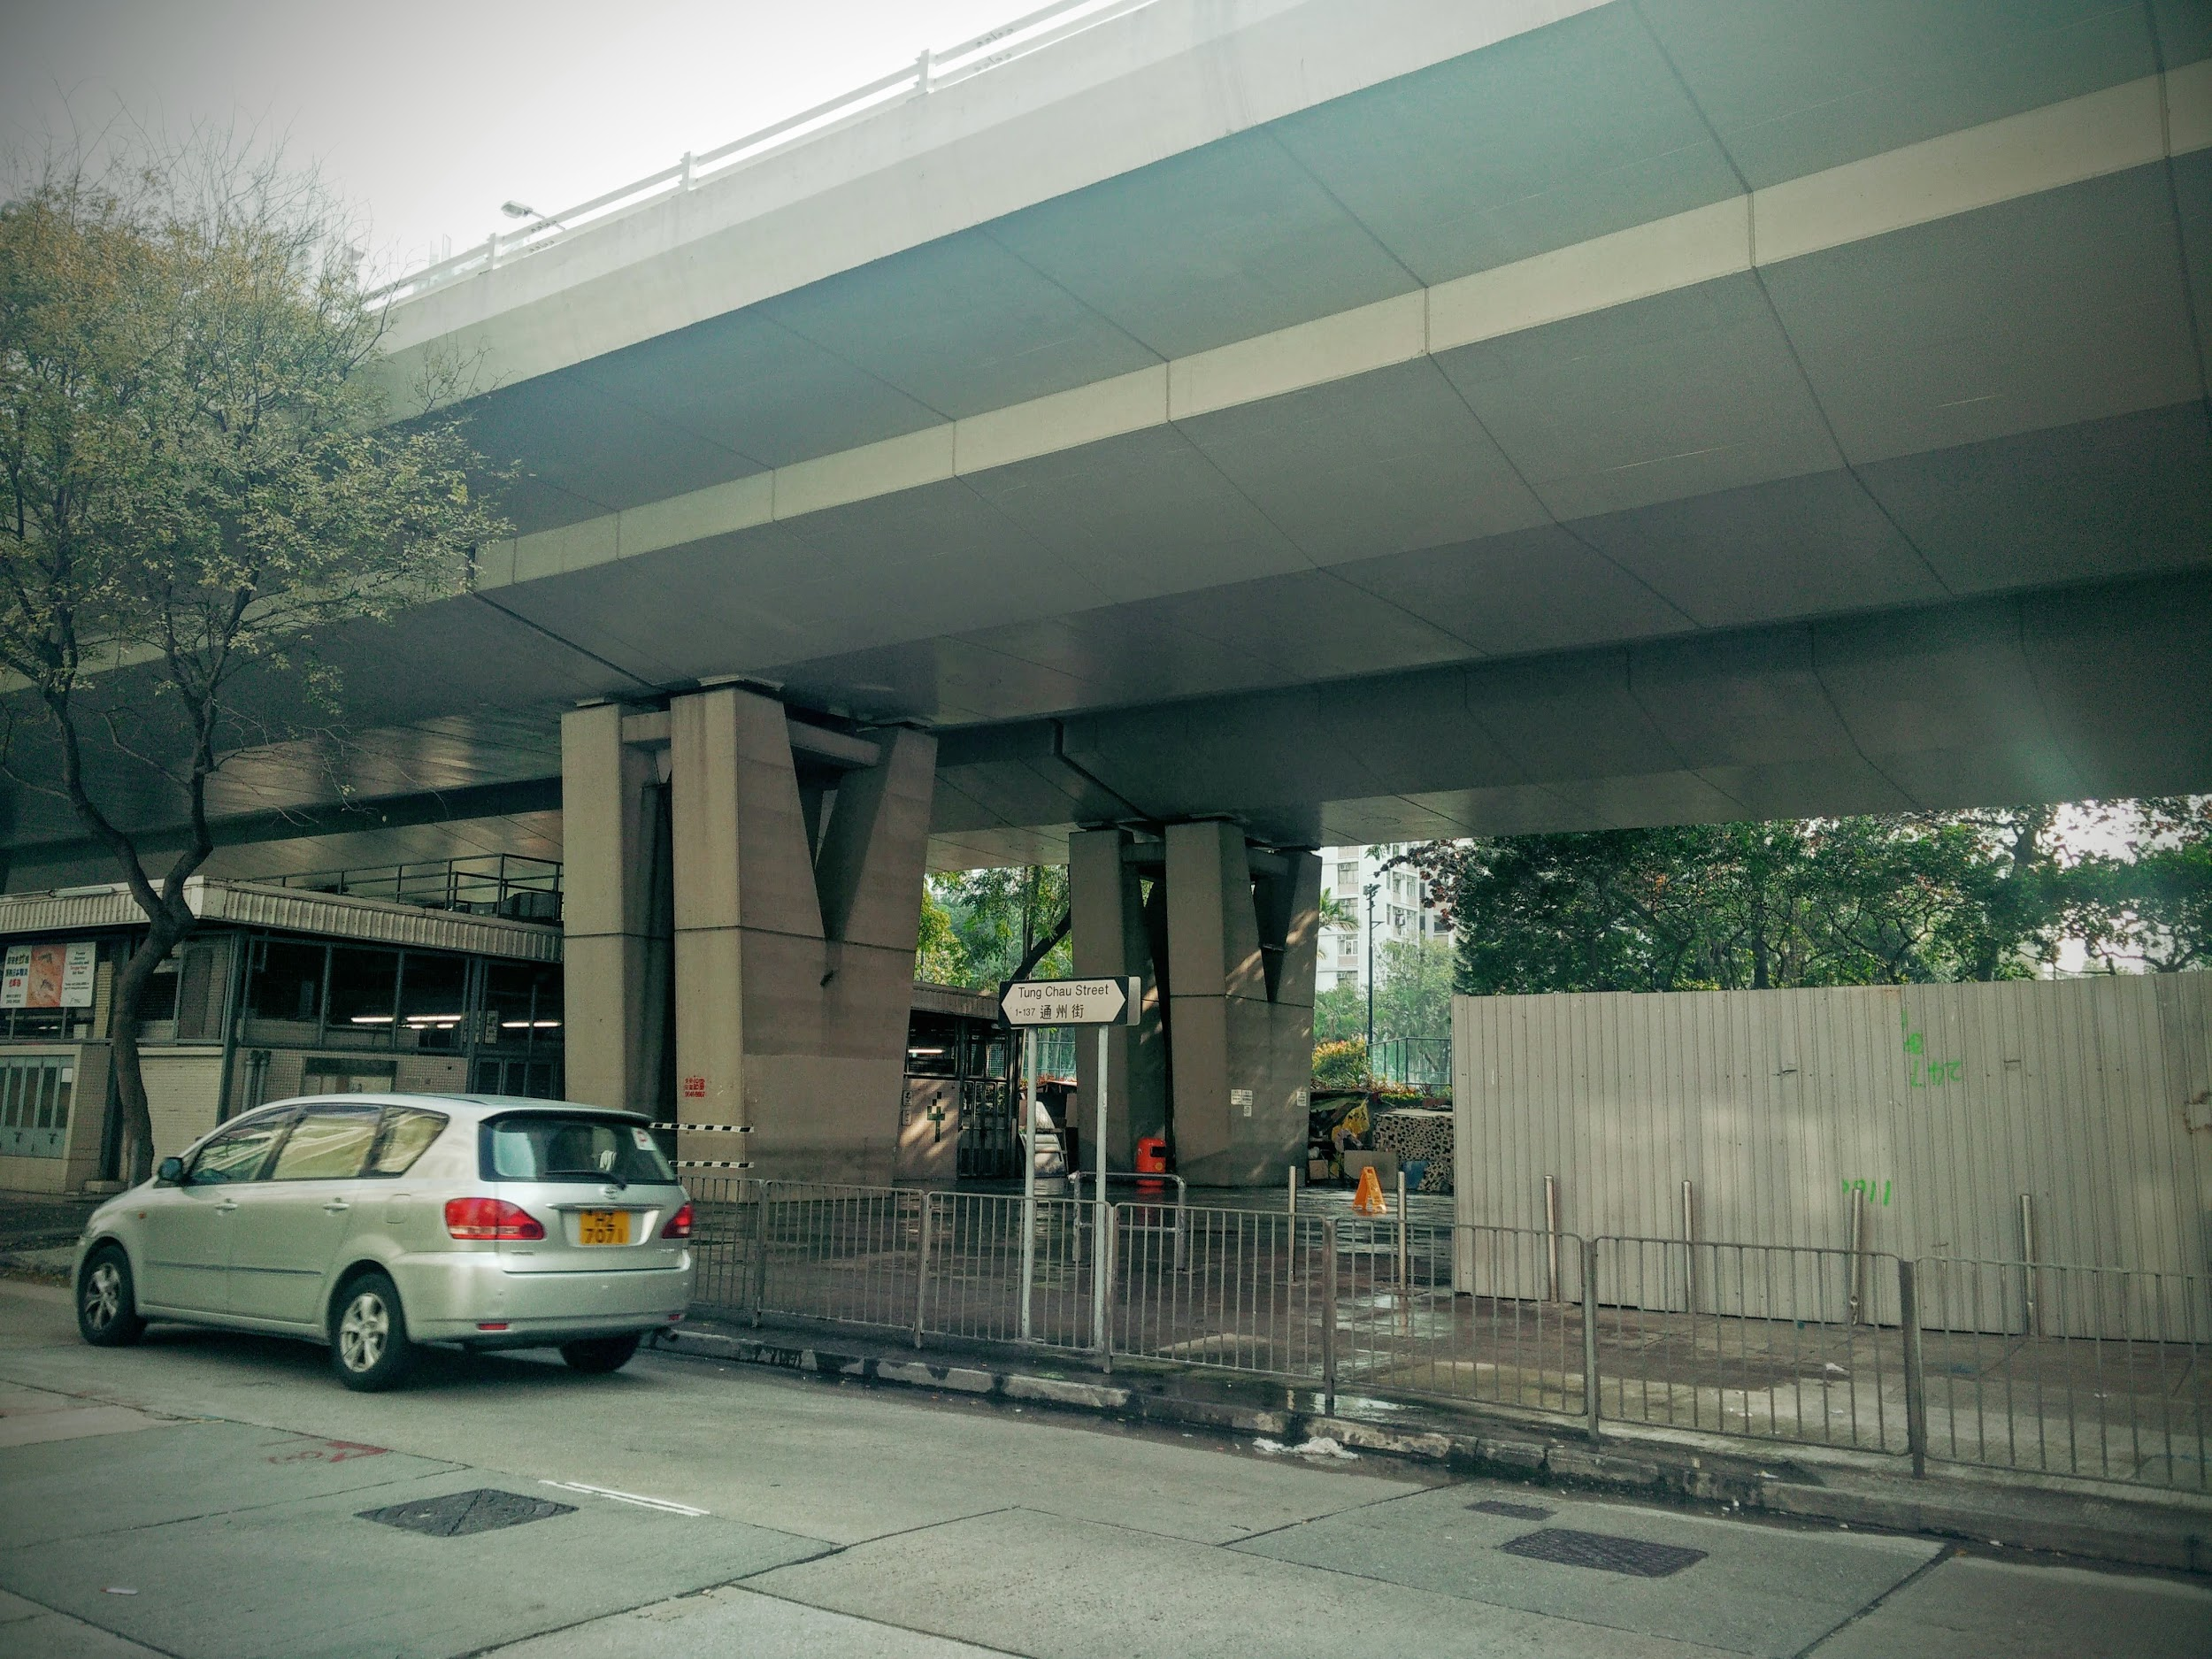

Image 1

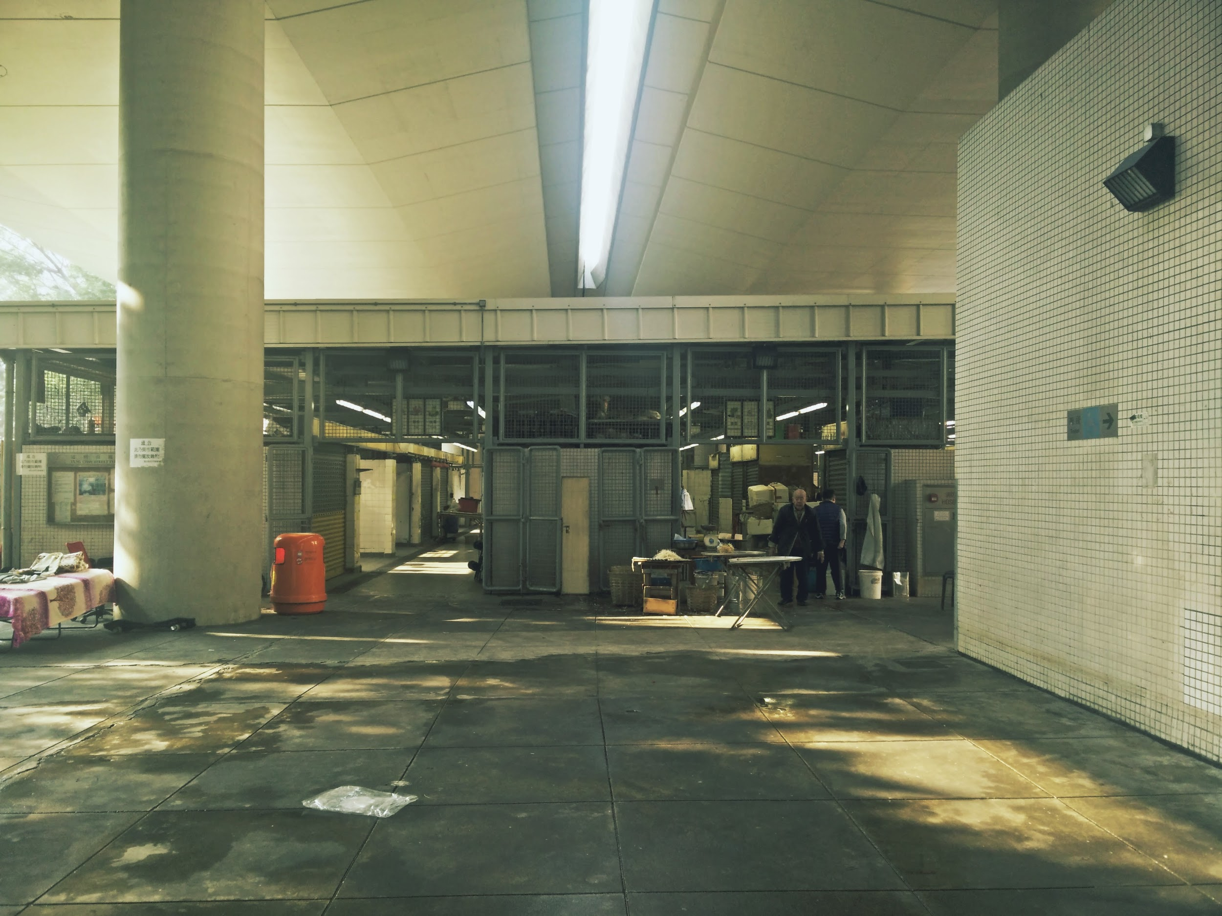

Image 2

The self-organisation process usually starts with the construction of one living space (Image 3). This quickly attracts other spaces, communal infrastructures (a communal table and chairs and a kitchen) and roles (doing the dishes, cleaning, cooking etc.). Once communal infrastructures are created, this attracts people outside of the particular community of people without homes, like elderly from the neighbourhood, who join to drink tea and chat.

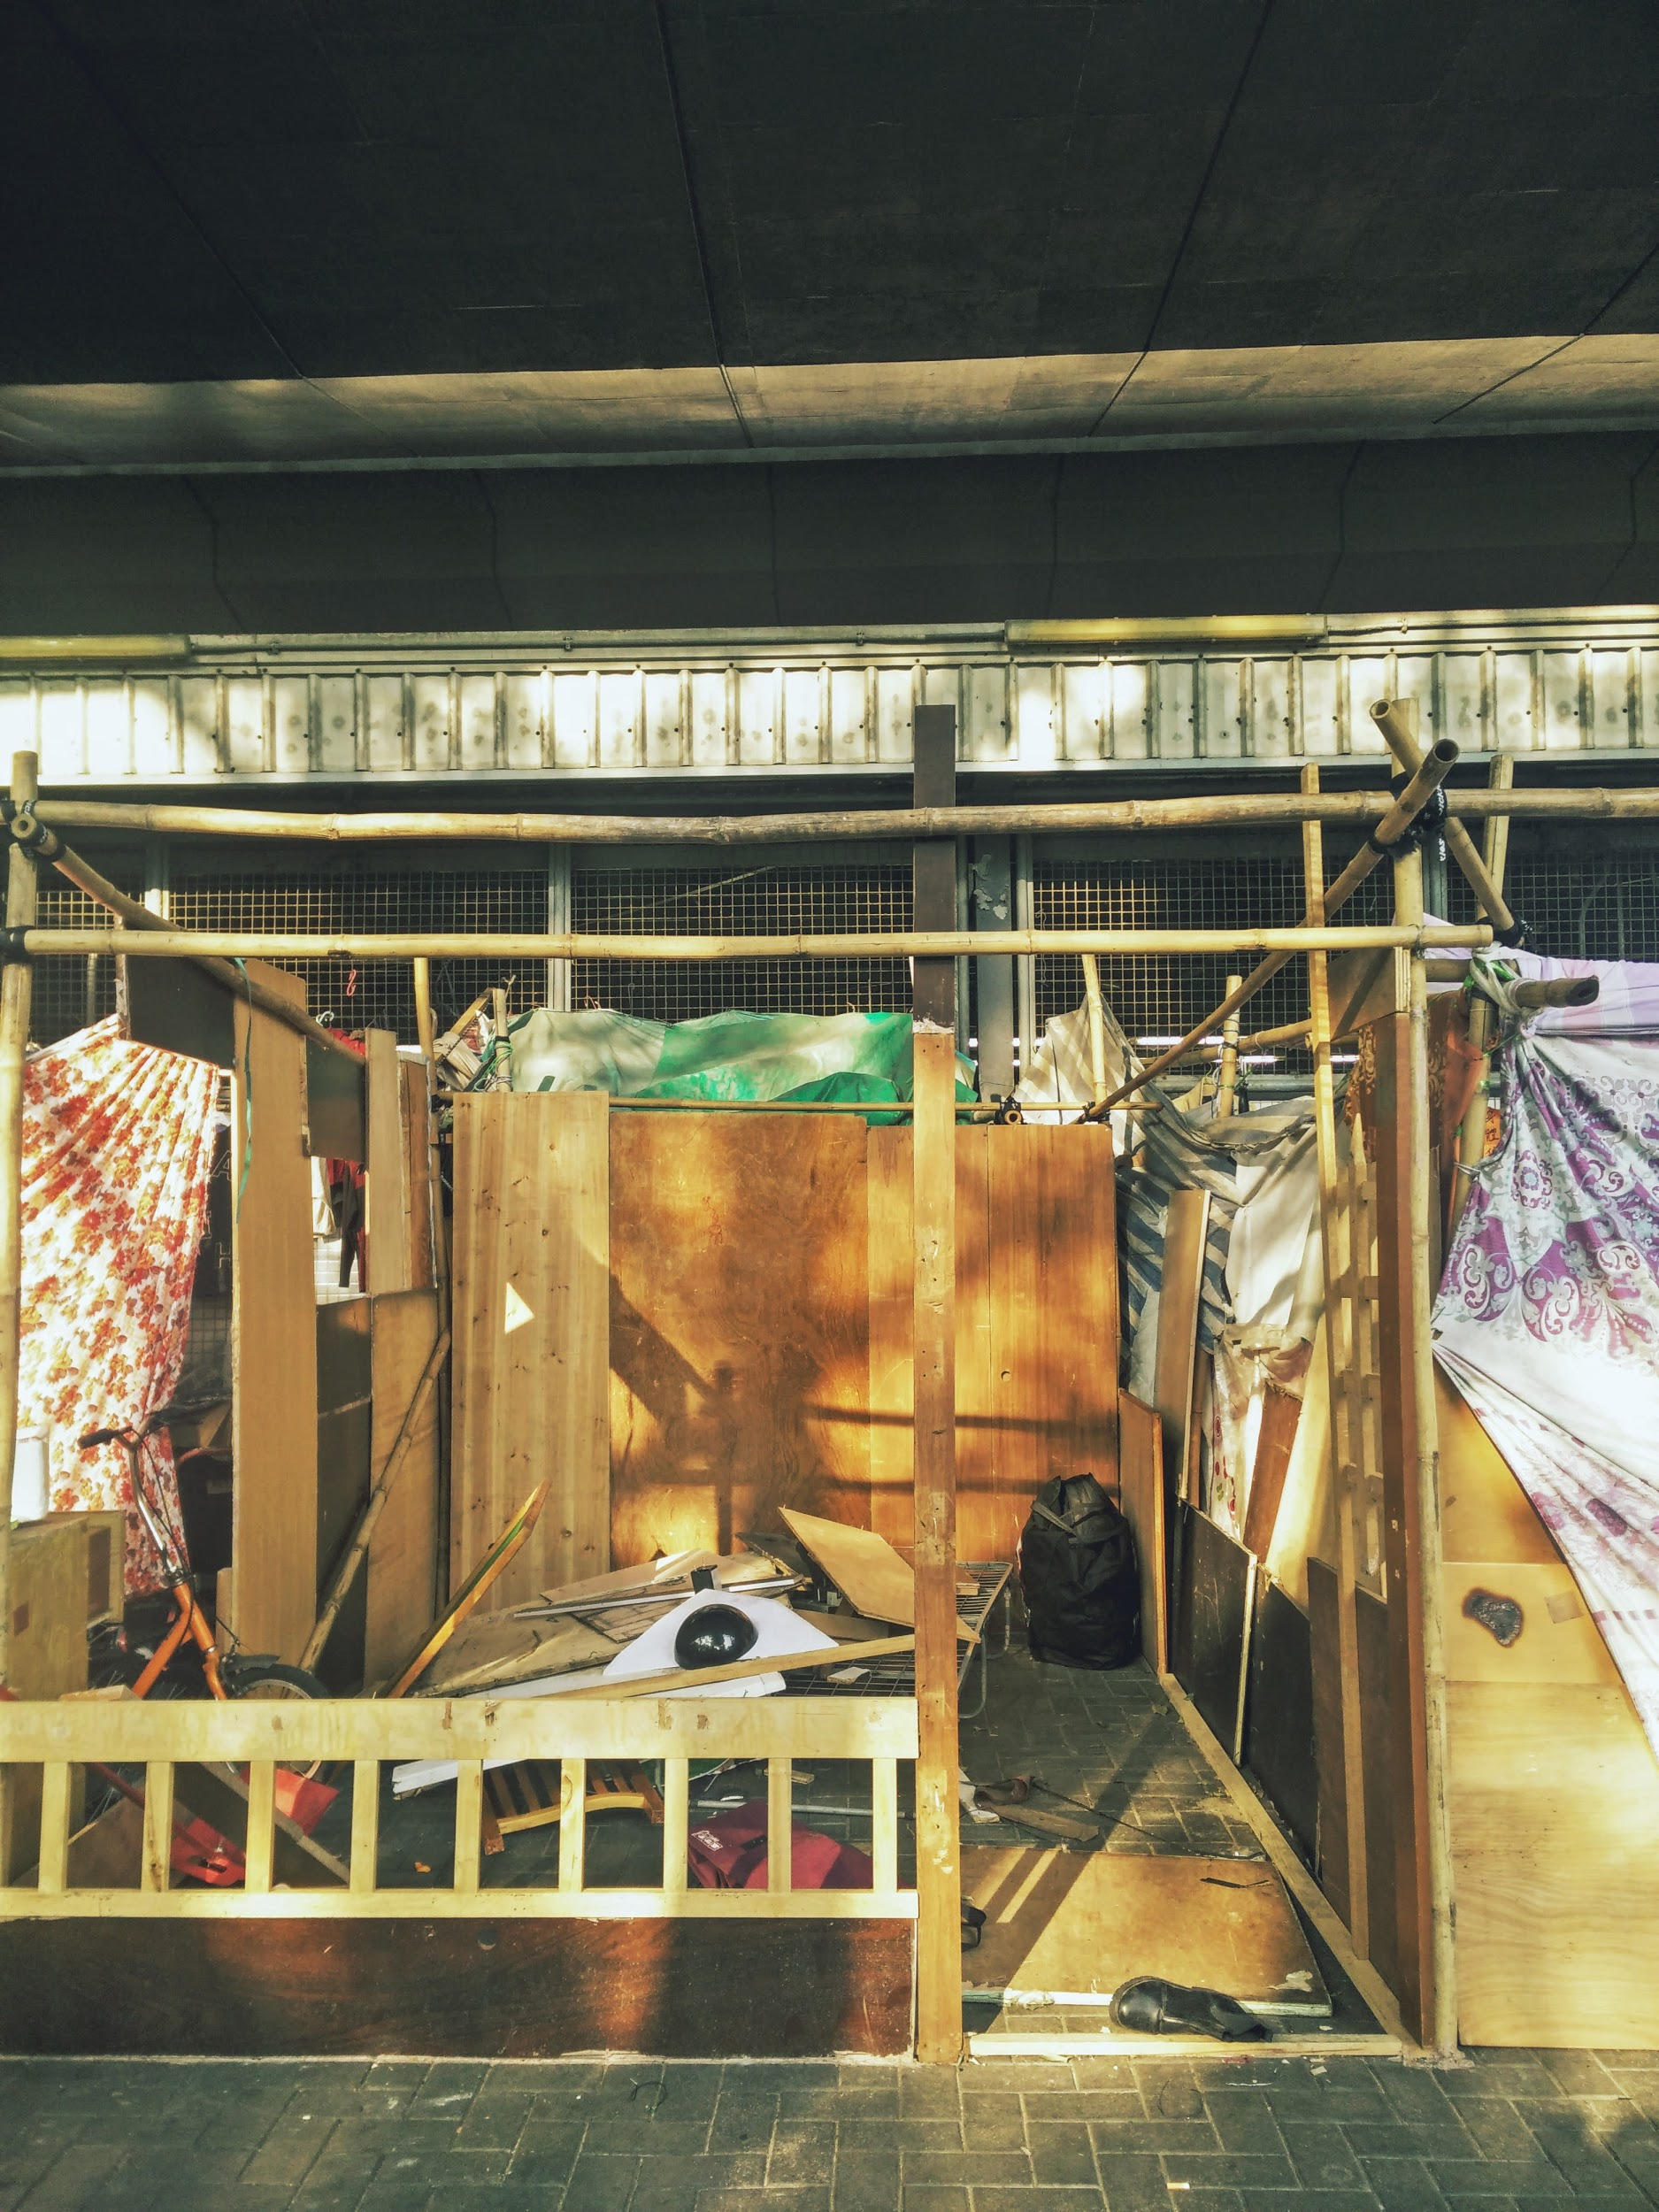

Image 3

The self-built homes in Sham Shui Po vary from being built on a temporary basis to being quite permanent. Roughly, the type of people using these spaces in Sham Shui Po can be divided in three groups.

The first group is the very temporary users. These are – among others – people without homes with a nomadic lifestyle, workers in the building industry, market sales (wo)men and the elderly gathering for a chat. Builders in the building industry use the living spaces as day offices and most often only during the period that a specific construction site is ongoing. However, as the plants outside of their office structures suggest, some have made homes out of the offices (see Image 4). Elderly use the communal spaces created by the people without homes or create new ones (e.g. by a sheet of newspaper or a mobile stool) to gather and chat. Similarly, market sales(wo)men create temporary market spaces with a newspaper as a marker of a space, but also via cars and carts, used both as storage and as demonstration spaces.

The second group is semi-temporary users. These are mainly local inhabitants of Sham Shui Po who rent subdivided flats during winter and come back to or rebuild their street homes in the summer, since the flats are too hot and too small to live in.

The third group is the permanent users. This group mainly consists of people without homes, with no Hong Kong residency. They are the most sedentary and thus build the most permanent spaces, since they have little opportunities to receive alternative shelter and support from the government. Therefore, these immigrant communities are generally the strongest in self-organising their communal spaces and roles. They make more intensive use of the water, electricity and sanitary services that are available under the crossing, since they appropriate the space in a more elaborate way than the more temporary users, in all its functions. Their houses are also the most developed.

We saw different types of street homes:

* Homes to live in during day and night (Image 3) versus temporary beds/sleeping rooms (Image 2).
* Daytime offices for builders (Image 4) and electronics tinkerers, next to electrical boxes (Image 5).
* Self-constructed markets (i.e. for textile with self-created roofs) (Image 6)
* Green spaces to plant, grow vegetables or enjoy nature (Image 7).
* Movable shops and storage spaces: cars rebuilt as shops and carts as storage space (Image 8 and 9).

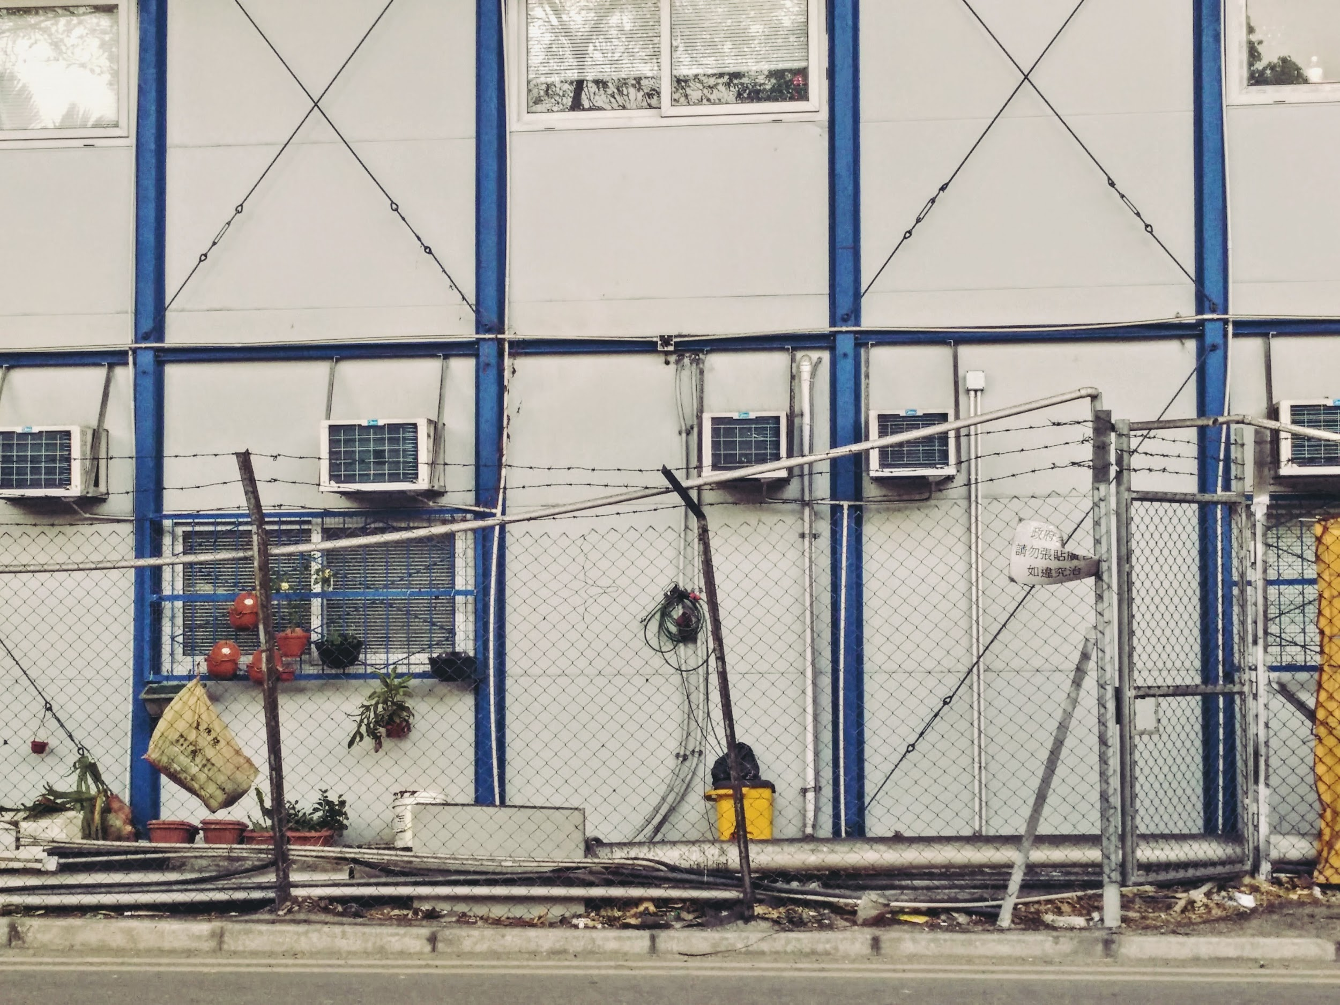

Image 4

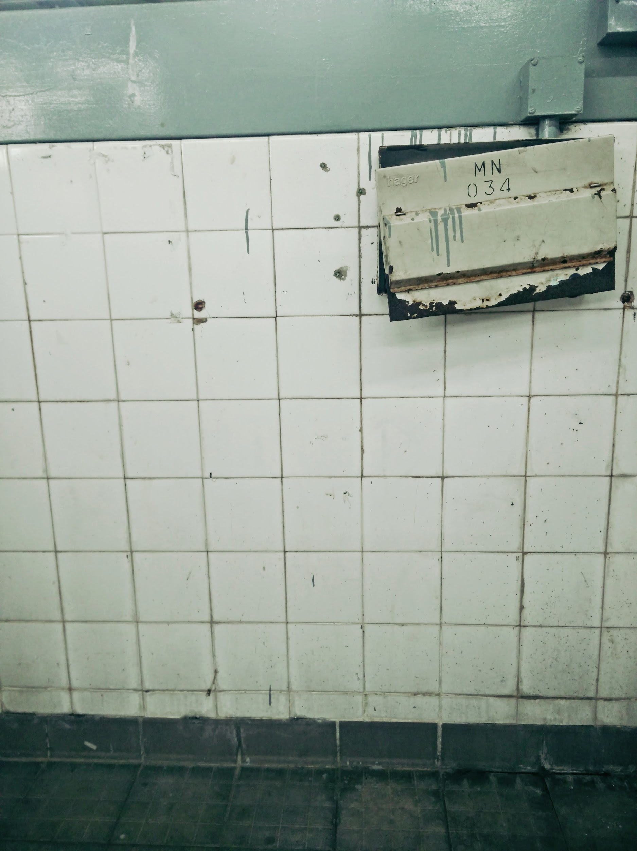

Image 5

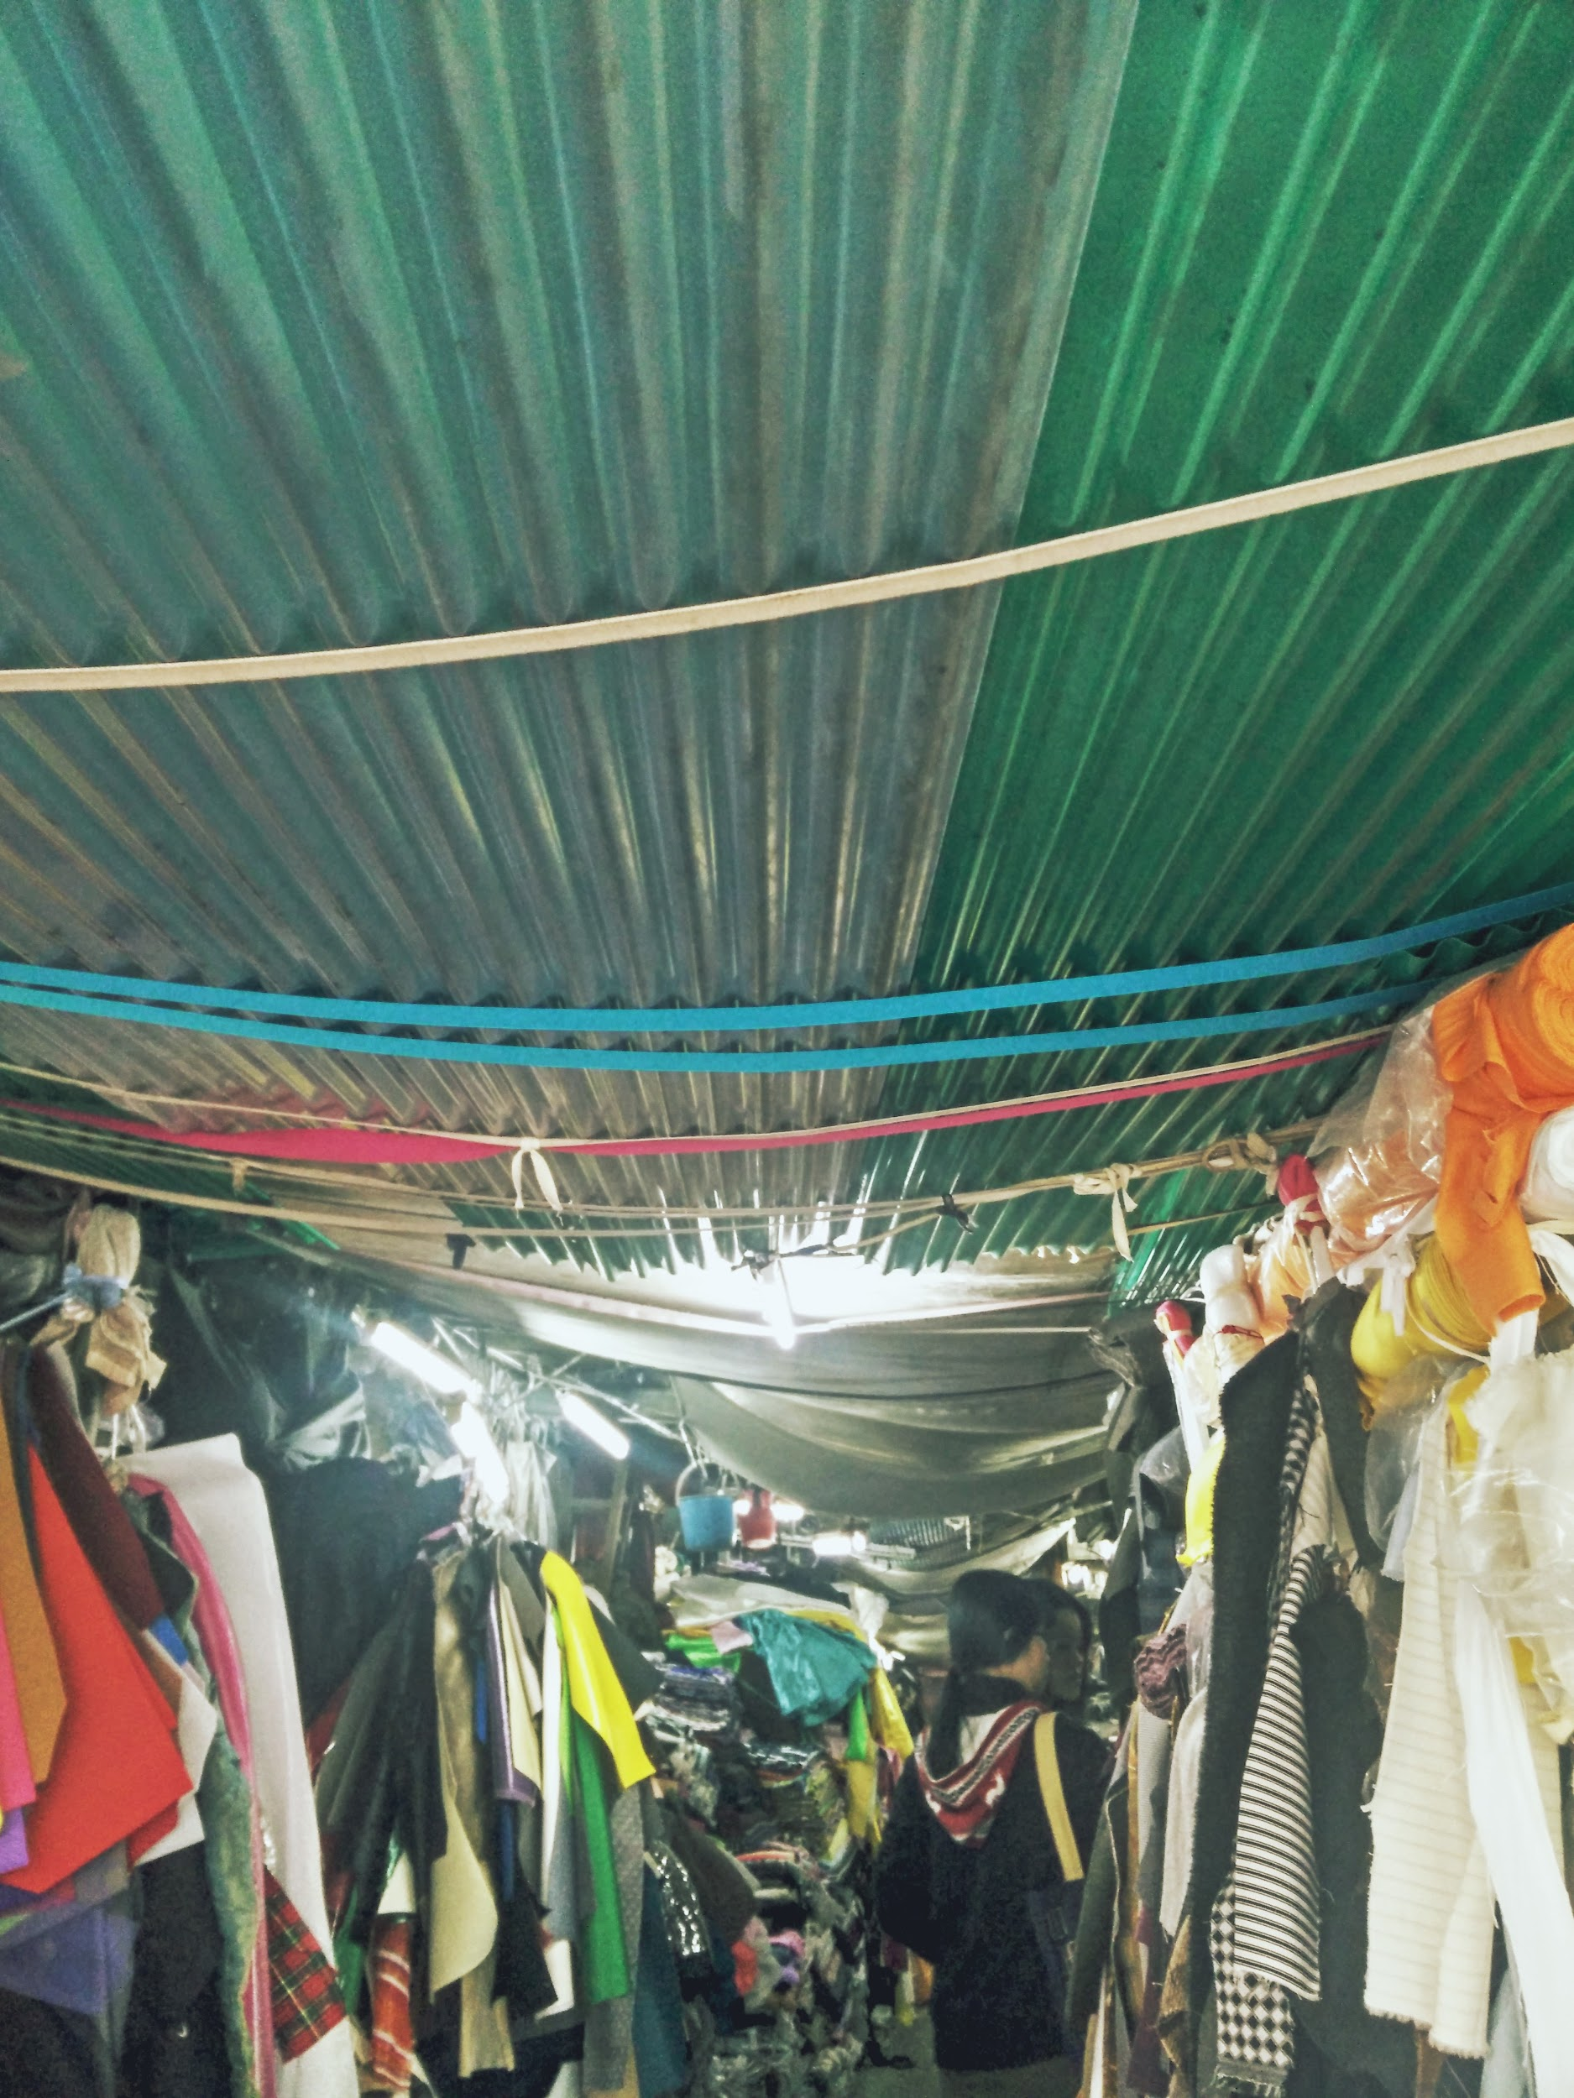

Image 6

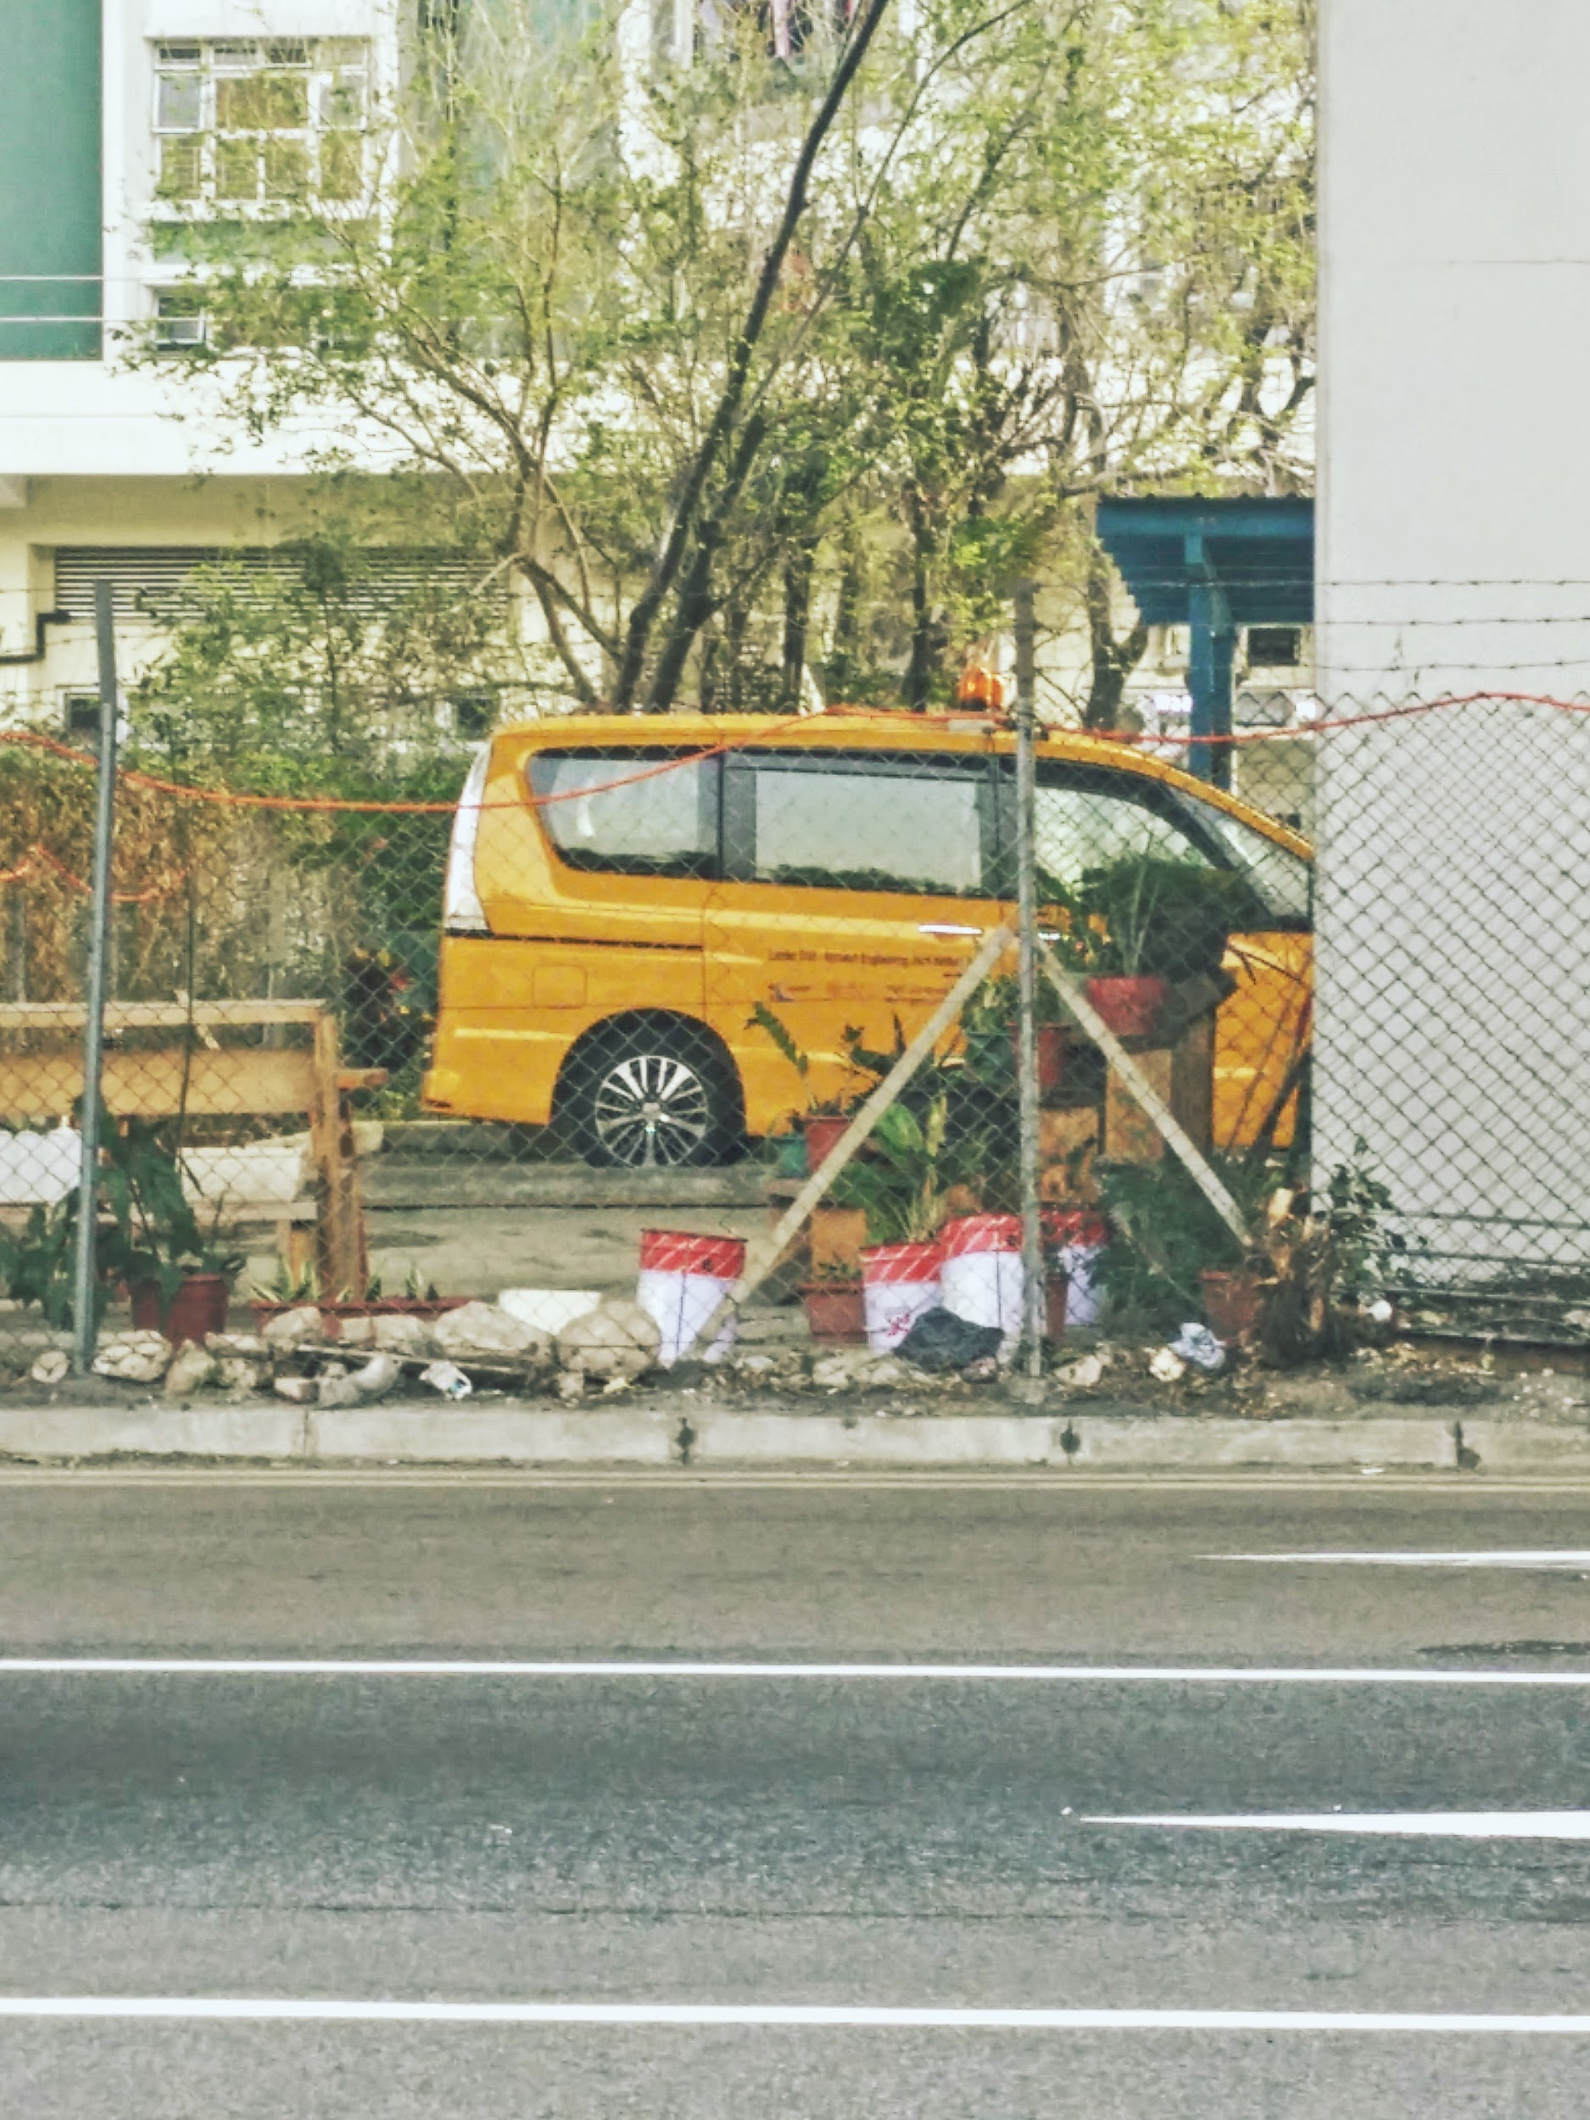

Image 7

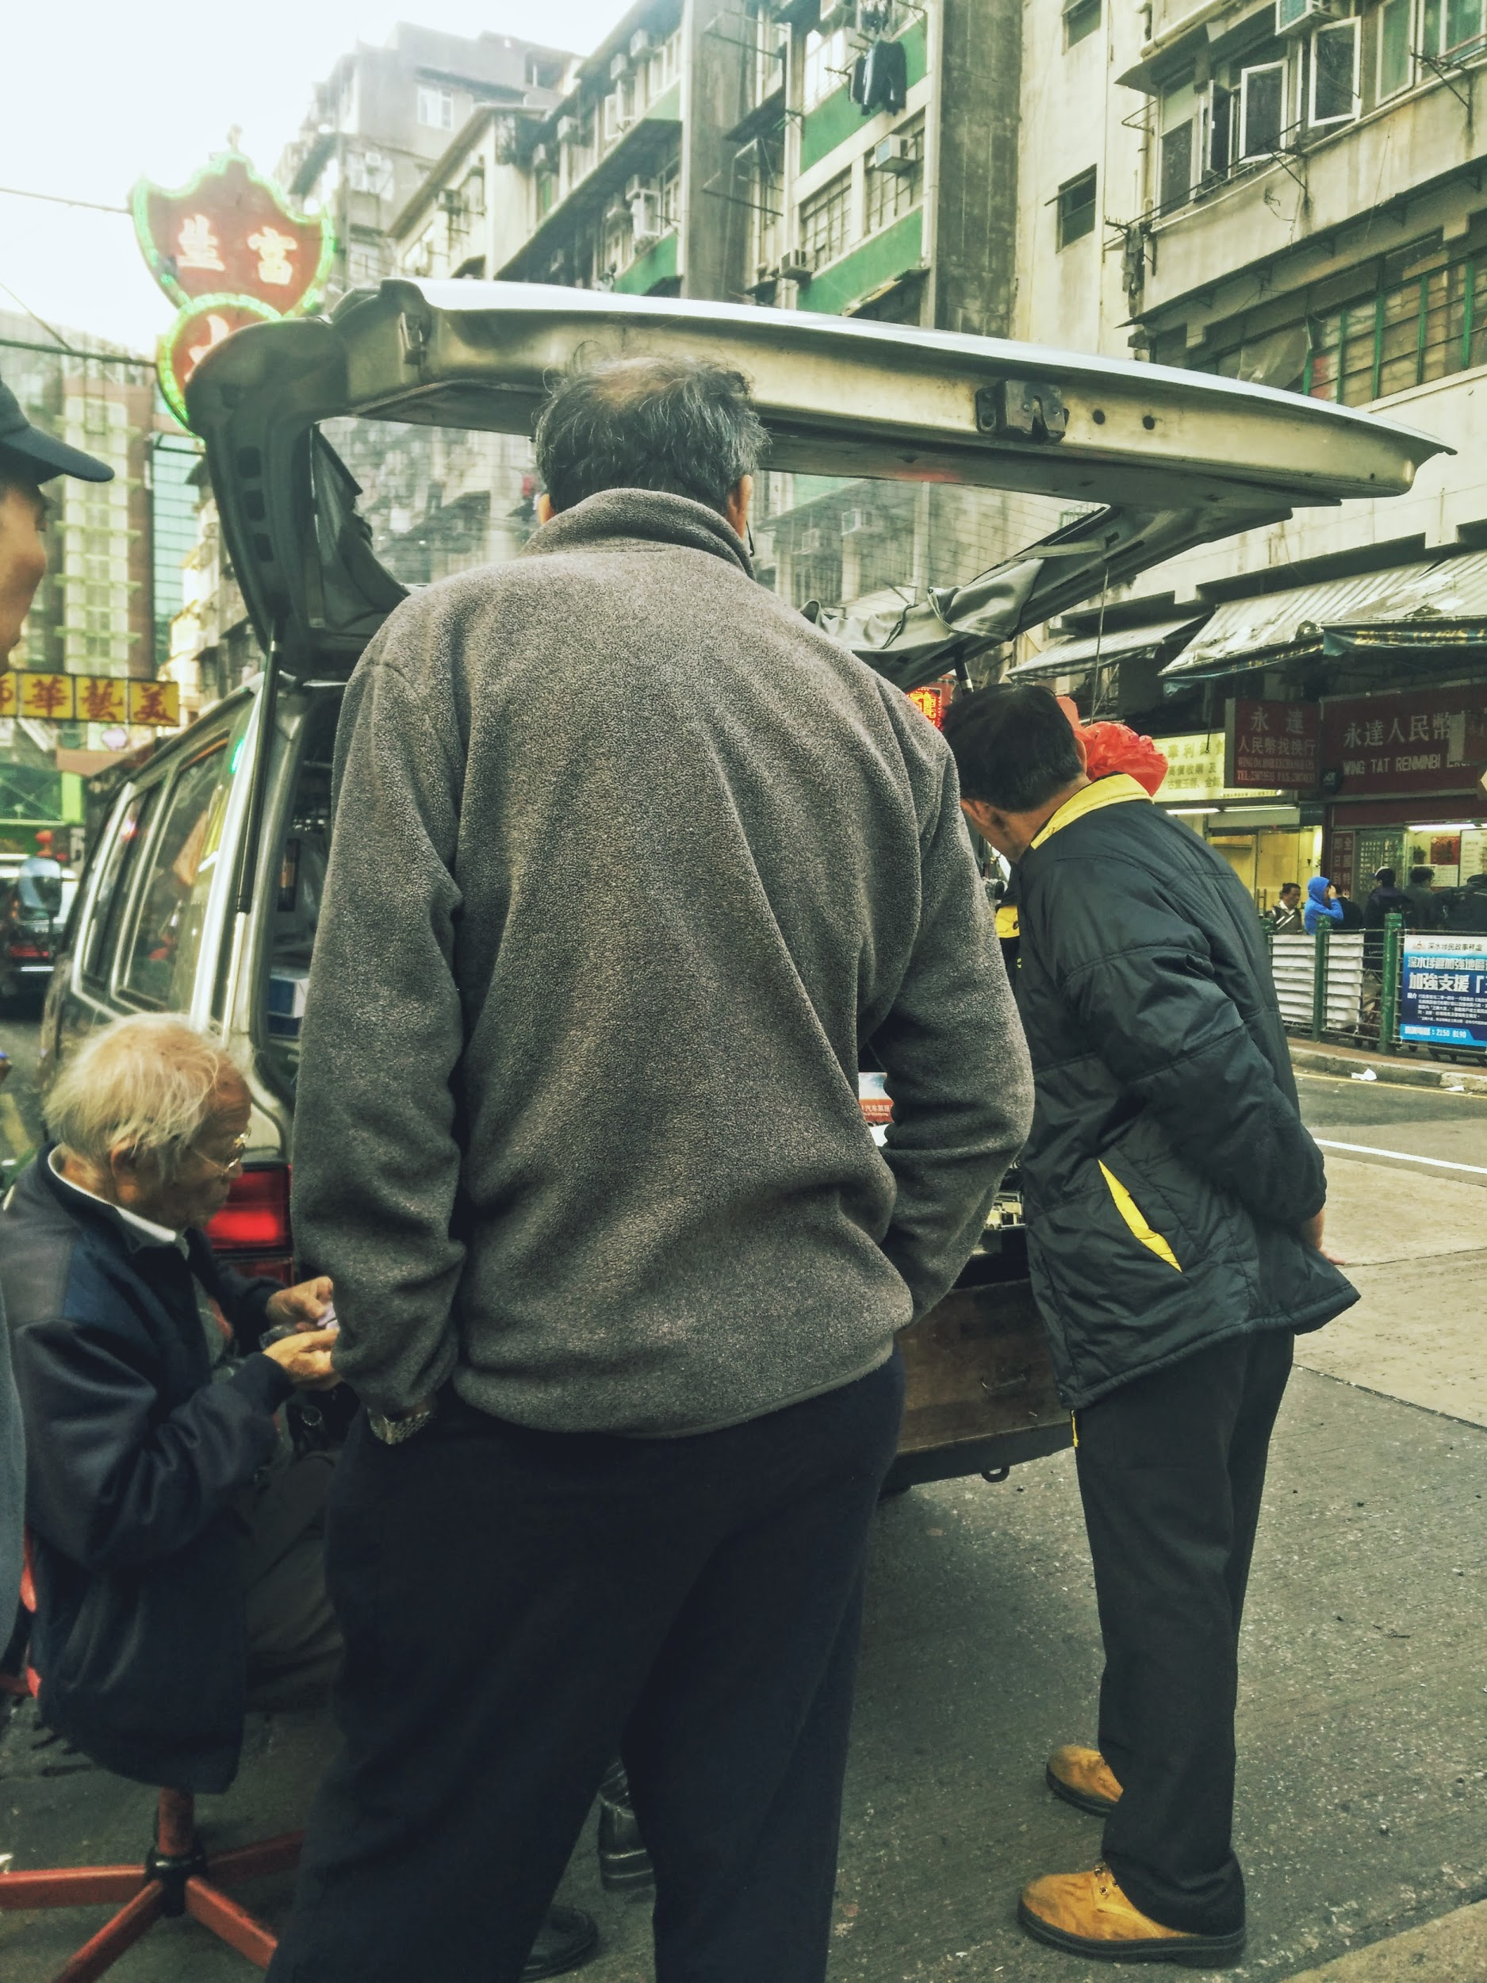

Image 8

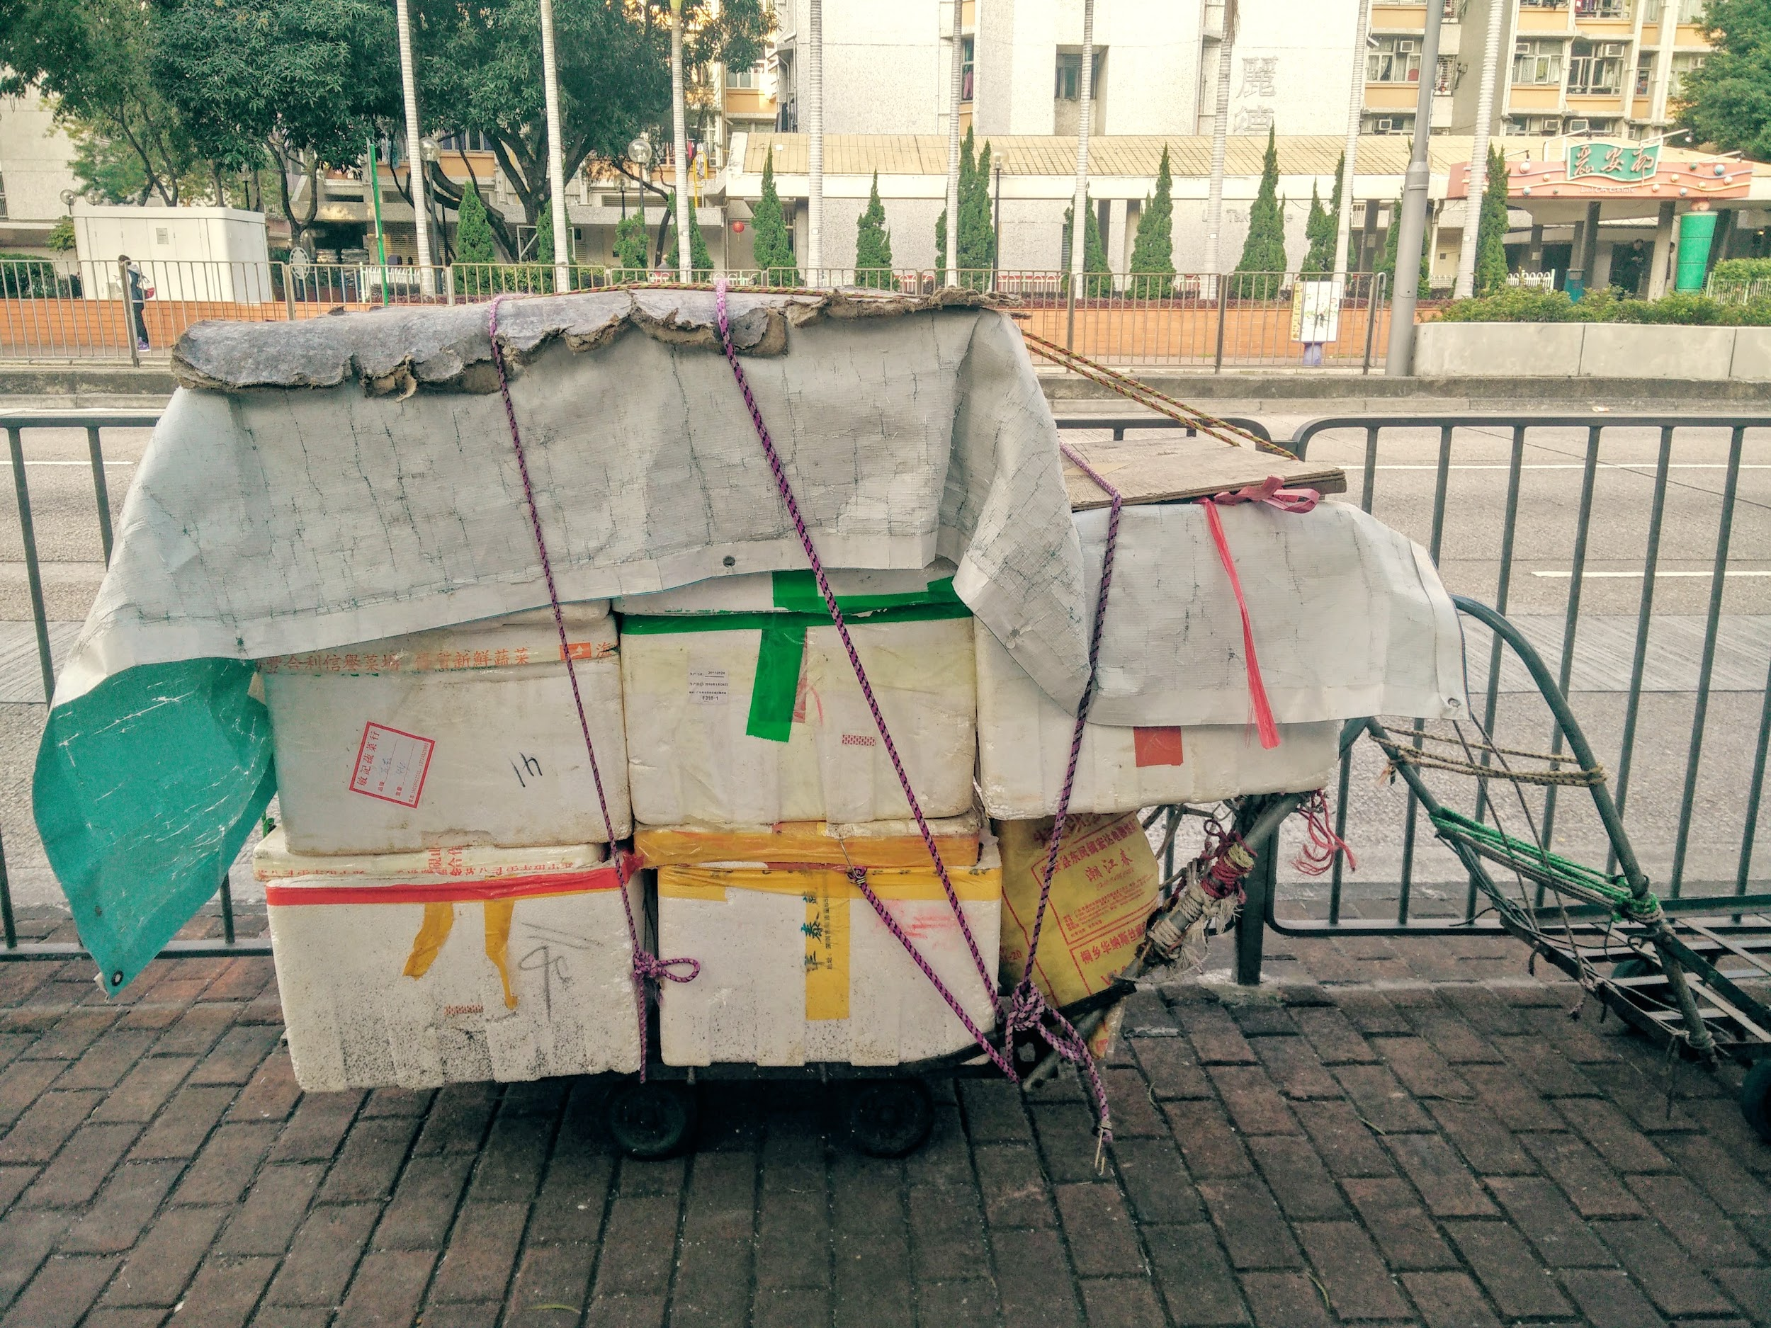

Image 9

**Discussion: Opportunities and Challenges for Self-Organisation driven PD** **on an urban scale**

The question that this case struggles with, and it is a common problem in other cases of self-organisation driven PD -, is, if and how the observations can be multiplied or scaled to design on an urban level. Many lessons can be learned from the structures themselves: how the roofs are created via textile strings etc. However, the question is also what the wider urban infrastructure can learn from this. Design on this larger scale can certainly acquire knowledge regarding the relational character of this design process. Needs recording, not correct. Here, close attention is paid to self-organisation and tapping into and expanding the human infrastructure, the knowledge and experience of people, for designing spatial plans for the future. This sentence needs reworking – its unclear what it is saying

This case also shows the potential of learning from and expanding the material relations: using the many crossings so typical to Hong Kong, to create anchor points (e.g. electricity poles, water connections and platforms) throughout the city to which temporary infrastructures (e.g. living, working, gardening, selling goods) can be attached.

**Self-organisation as Part of a Larger PD System**

In this design process it became very clear that self-organisation cannot be studied in isolation. The self-organisation in building homes quickly became an intrinsic part of the relational network of the designers: the designers, their visitors, the events they organised (e.g. 100 in 1 day interventions). The designers started organising co-design sessions, inviting the self-builders to share their knowledge and experiences with the design community. During the two years of research, the position of this self-organising practice in relation to governments and private actors also became clear. The government has removed the temporary living structures once and is planning to do it again. The environment around the temporary homes is becoming one big building site, since the old Sham Shui Po is quickly being replaced by new high rise private and public buildings. These changes understandably produce some tension with the informal housing and communal spaces.

**The role of the designer/researcher**

It is clear that designers in this case have developed a very close relationship with the self-built community, which requires the designers to continuosuly reflect on their own role and position in the design process; especially in relation to the other actors involved. This self-reflection puts some positive pressure on the designers to design processes and artefacts that recognise the self-builders’ agency and desires. It also produces some challenges, because of their close involvement they can also become blind to the possible threats of such street living. Threats like drug abuse, unstable structures or further the fear of designing, because no design proposal will completely satisfy all community members.

**The concepts permanent versus temporary**

The living spaces in the streets fundamentally question what is permanent versus temporary. Some of the very temporary structures, appeared to be quite permanent living structures. At the same time, what were intended as permanent living structures are built in such a way that they can be easily deconstructed, and thus are characterised by their temporary and flexible character.

**And what about the future?**

Engaging with the history and contemporary practices of self-organisation in street living in Hong Kong, has revealed challenges in crossing borders between 1. the community and the urban scale, 2. the introvert self-organisation practice and the extravert PD process, 3. the design researcher in relation to the self-organised communities and 4. temporary and permanent housing. More informed, conscious and careful crossing of these borders in self-organisation based PD, allows these 4 challenges to become opportunities for designing street living in the future.

Through crossing these borders this study advocates a new potential for designing future street living. On a macro level, Hong Kong’s many crossings revealed themselves as offering many opportunities for new types of living space to develop: for sleeping, meeting, working or leisure thus informing the overall practice of designing the city, It showed that cities can provide some basic infrastructure that allow forms of street living to develop, initiated by – for instance - youngsters, elderly, people without homes or citizens whose homes are too small. The research cited in this article has given insight into potential infrastructures for the future: strong local community hubs that include people from all layers in society, hotspots offering basic electricity, water and sanitation, basic attachment points for constructions, such as platforms and roofs.

On a more theoretical level, we could say that this research demonstrates self-organisation as a rich resource for design that can never be looked at in isolation. When these practices are subject to and part of a design research process, self-organisation can hardly be defined in an introverted way. It is part of an evolving human and material infrastructure, in which designers, people from the studied community, policy makers, private companies and material aspects of the city’s space are all part of giving form to the future of a city.

References

* Boonstra, B. and Boelens, L. (2011). Self-organisation in urban development: towards a new perspective on spatial planning. Urban Research and Practice, 4 (2), 99-122.
* Bradbury, H. Reason, P. (2003). Action Research. An Opportunity for Revitalizing Research Purpose and Practices. Qualitative Social Work, 2(2), pp. 155-175.
* Brynskov, M., Carvajal Bermudez, J., Fernandez, M., Korsgaard, H., Mulder, I., Piskorek, K., & De Waal, M. (2014). Urban interaction design: Towards city making. Neuhausen, Germany: Urban IxD Booksprint.
* DiSalvo, C., Clement, A., & Pipek, V. (2012). Communities: Participatory Design for, with and by communities. In Routledge International Handbook of Participatory Design, edited by Jesper Simonsen, and Toni Robertson. 182-210. New York: Routledge International Handbooks.
* DiSalvo, C., Clement, A. & Pipek, V. (2013). Communities: Participatory Design for, with and by communities. In: Simonsen, J. & Robertson, T. (Eds.). Routledge International Handbook of Participatory Design, pp. 182-210. New York: Routledge.
* Goodspeed, R. (2015). Smart cities: moving beyond urban cybernetics to tackle wicked problems. Cambridge Journal of Regions, Economy and Society, 8(1), pp. 79-92.
* Horelli, L., Saad-Sulonen, J., Wallin, S. and Botero, A., (2014). When self-organisation and urban governance intersect: Two cases from Helsinki. Using ICT, Social Media and Mobile Technologies to Foster Self-Organisation in Urban and Neighbourhood Governance conference. Delft: The Netherlands.
* Gunn, Wendy, Ton Otto & Rachel Charlotte Smith (2013). Design anthropology: theory and practice. London, New York: Bloomsbury.
* Manzini, E., & Rizzo, 2011). Small projects/large changes: Participatory design as an open participated process. CoDesign, 7(3-4), pp. 199-215.
* Schreurs, J. & Kuhk, A. (2014). Design and scenario: building blocks for an ecological perspective on self-organisation. In: Proceedings for Design, Social Media and Technology to Foster Civic Self-Organisation. Hasselt: University Hasselt.
* Tai, C. Ge, C. Lee, G. (2011). Hong Kong’s squatter settlements – from transit points to cherished homes. Available at: <http://varsity.com.cuhk.edu.hk/index.php/2011/05/squatters/>.

*Dr Liesbeth Huybrechts made a PhD about the relation between digital media, art, design and participation. Currently, she is Postdoctoral researcher in the area of participatory design and spatial transformation processes in the research group* [Arck](http://www.fac-ark.squarespace.com/capacity-building), University of Hasselt. She is involved in the Living Lab [The Other Market](https://deanderemarkt.wordpress.com/), a space for reflection and action on the future of (space for) work. She co-founded the research group [Social Spaces](http://designandthecity.eu/speakers/liesbeth-huybrechts/www.socialspaces.be) exploring the social qualities of design and art.

(Liesbeth, please check…)

# 04// Self Build Community Cases in Hong Kong _ Who are they?

# 05// Interview with Prof Wong Hung _ The Society of Homeless

At the Chinese University of Hong Kong, 17th June 2015

Louise Wong and Will Davis

## On Before and After Occupy

In the old days, a year before the umbrella movement, they did not have these kinds of fixtures (semi-permanent structural fixtures), so this became a part of the occupy movement’s aftermath—most of the material they used could also be found in occupy Mong Kok. These heavier wooden structures for example make it cooler, less wet. The government tries to use a particular method to push them out; not by force, but by cleaning the floor: weekly or even daily, somebody will come to clean the floor and the occupants would have to move their belongings, but they need to clean and water it, they say it is hygiene, something like that. After occupy, more people joined the community and became more organized, they are building; more fixtures, more items and so on. At this point the occupants said “we’ll clean ourselves”. So it has become more formal—in the older days there wasn’t as much cookery, it was just a place to sleep at night.

If you look at for example how the homeless sleep outside the Hong Kong Cultural Centre at night, it is much more floating, you are only allowed to be there after 11pm, and you have to wake up at 6:30am to move on. So they are another kind of mobile sleeper, using lighter materials. Two years ago this is also how it was at Sham Shui Po (SSP)—so it is a new phenomena since occupy central, the use of these materials. It is some kind of occupy, an occupation, but still not necessarily politically motivated.

The structure that the site needs is that it must be close to a toilet, water, electricity I’m not sure, now they may be using that for cooking and so on. Another factor is the flyover, it provides shelter from rain and sun.

**Is the self-built community an example of a heterogeneous social network?** Because you mention that a homogenous social network is actually a fragile model of independent support, because the community needs to be able to support itself. So if the social network is more heterogenous, linking different socio-economic groups in some way…

Using our vocabulary we would say it is bonding social capital or bridging social capital. Bonding social capital is the social network between those that already know each other, they may have family from the same village, the same background. But bridging is a certain kind of social network, it is heterogenous, it is involvement in parts that you are not familiar with, perhaps you are not from the same background. I would say in that part of SSP it is still bonding social capital rather than bridging social capital, so I just introduce this as three parts of a village (the drug users or sellers, the elderly or disabled, the vulnerable minority groups), but they are not of the same village, they do not have much interaction.

Another way of talking about a social network is that sometimes they are quite isolated or lonely, so they need each other, they need some kind of mutual help, I would say now after getting to know their lives. One way round, many of these elderly and disabled are in the middle, they need to get help from social workers, and they can get access to public housing. Some say however that it is more connected to social relations; on the street they can have more conversation, friends, some checkups, they can be in the park—in this area there is quite a lot of food assistance, someone will come to check up and provide food.

## Different Mutual Relationships

Every day there is some kind of food supply. These kind of mutual relationships—have about two or three friends. They may not trust everyone in this community; sometimes people steal things or borrow money that they don’t return. So they try to maintain this shallow relationship with one another, at the same time of there being a lot of mistrust and problems. You can see it is not just a large village where everybody shares everything. There is still the question of how to protect your own belongings.

The difference is; if they go to the public housing, nobody will notice you, nobody is concerned about you. They won’t know their neighbours—it is worse than here. This is not ideal, but more individualised than the public housing. The elderly say “I would die and my neighbours would find out by the smell” but here, I also still have someone “if I am sick, I know someone who can call the ambulance”—isn’t that strange?

People here still belong to something, they are still in the memory of someone, it is quite an interesting phenomena as a sociologist to study, when we see what kind of care people want—not just money, not just accommodation, so we want to use this word homeless rather than street sleepers—but they do not have the care or belongingness of a home—in this case (of the self builders) it is a certain kind of belongingness, a certain kind of interaction with the public. I think it is quite an interesting phenomena when we talk about if this is a public space or a private space.

## Self-built Homes

It is much like a home; two or three people will share a space and be concerned with one another.

In the old days the Hong Kong people solved this problem with self-built structures along the hillsides of Sham Shui Po, Shek Kip Mei, along Lion Rock, and we still have some work on the five villages of this loop. These are not just wooden structures, they are stone, they are more established, this is a real village. There is more of a social structure. The population has however dropped from 3000 to maybe 1000 people or so, most of them have moved out. They have low-houses, more permanent structures use a tin-roof and so on, but I think twenty years ago we tried to evict and demolish all of these settlements. There was a contract, that if your house was registered, you would receive public housing once you were evicted. The public housing was much more safe: no typhoon, no fire, no landslides. So that is why there is this large public housing movement there. Also it is down to the allocation, if you are a resident in this kind of urban area and they demolish your home, for the newcomers, for example new Africans, you can only apply for the public housing in the New Territories. It’s a big difference between Sham Shui Po and the New Territories! You cannot find jobs there, there is a long waiting list, and many applicants want public housing in Sham Shui Po. So this is the dynamic.

I have some worry, because just opposite the flyover there is a big URA development project, there will be a large residential luxury apartments. If these kind of residents come, they will complain “why are there so many street sleepers here, why don’t the government do anything, the price of my flat should drop”

## Boundary?

So this strip is a kind of boundary somehow?

Many of the residents here are the elderly, they are just interested in the market and the park, for the elderly they love to do shopping at the morning market, they are part of the market lets say. It is a contract or kind of consensus between the street sleepers and the morning market. The street sleepers here are part of a larger phenomena—if they want to clear all of these kinds of people they also need to clear the morning market. This market is acting as some kind of protection, in this space you have pure residential and business. It is a very interesting phenomenon, in the morning it is quite noisy! But the homeless people don’t complain.

There is one very interesting story that I should tell, quite an astonishing story. One street sleeper would sleep in the old Star Ferry terminal, Tsim Sha Tsui to Central; he slept in the Central pier. He had been sleeping there for more than twenty years when we approached him. Why did he choose this place as his house? Toilet, shelter, light, business. What kind of business? Many Filippino maids would sell things here on Sundays at a mini market, but what about the storage of their goods during the weekdays?

Ah so he stored things for them?

Yes! He looked after their trolleys. There are between seven and ten trolleys around the area that he sleeps. One day the government took all of these things whilst he was in the toilet, and he lost everything, so now he is crazy about that. After that day he doesn’t visit the toilet anymore! It's a very interesting story about space; private, public, government, cultural and also against it.

# 06// Phenomena _ how do self-builders live?

# 07// Editor note: Permanently Temporary: Home of Urgency in Urban Hong Kong _ Yanki Lee & Sara Wong

1. According to UN-HABITAT, around 33% of the urban population in the developing world in 2012, or about 863 million people, lived in slums. Of which the proportion of urban population living in slums was fourth-highest in East-Asia (28.2%). ["State of the World's Cities Report 2012/2013: Prosperity of Cities"](http://sustainabledevelopment.un.org/content/documents/745habitat.pdf) (pdf). UNHABITAT.
2. Rudofsky first brought the pairing of ‘vernacular’ and ‘architecture’ together: ”For want of a generic label we shall call it vernacular, anonymous, spontaneous, indigenous, rural, as the case may be.” — Rudofsky, *Architecture Without Architects*, page 58 (Museum of Modern Art New York)
3. From the chapter ‘Unslumming and slumming’ in *The Death and Life of Great American Cities* by Jane Jacobs. (1961) Vintage Books, NY.
4. This idea comes from *The Edgeryders Guide to the Future: A HANDBOOK FOR POLICYMAKERS & DESIGNERS OF POLICY-ORIENTED ONLINE COMMUNITIES*, a publication funded by the European Council on how design-oriented thinking can affect public policy and innovation. For download: <https://book.coe.int/eur/en/youth-other-publications/5792-the-edgeryders-guide-to-the-future.html> (accessed on June 3rd 2015).